FIRA Brazil Open 2026

Mission Impossible Foresight

Save The Queen
Jacky Baltes <jacky.baltes@ntnu.edu.tw>

Introduction
The Mission Impossible Foresight Mission -- “Save the Queen” is a challenge developed for the FIRA Brazil Open 2026 Mission Impossible competition. The challenge focuses on software development.
The goal is for a robot to track a simple rectangular path. Five playing cards will be selected by the referee from a set of cards. The robot must drive around the track, scan and identify the cards and then stop as close a possible to the target card on the opposite side of the track.

Playing Field
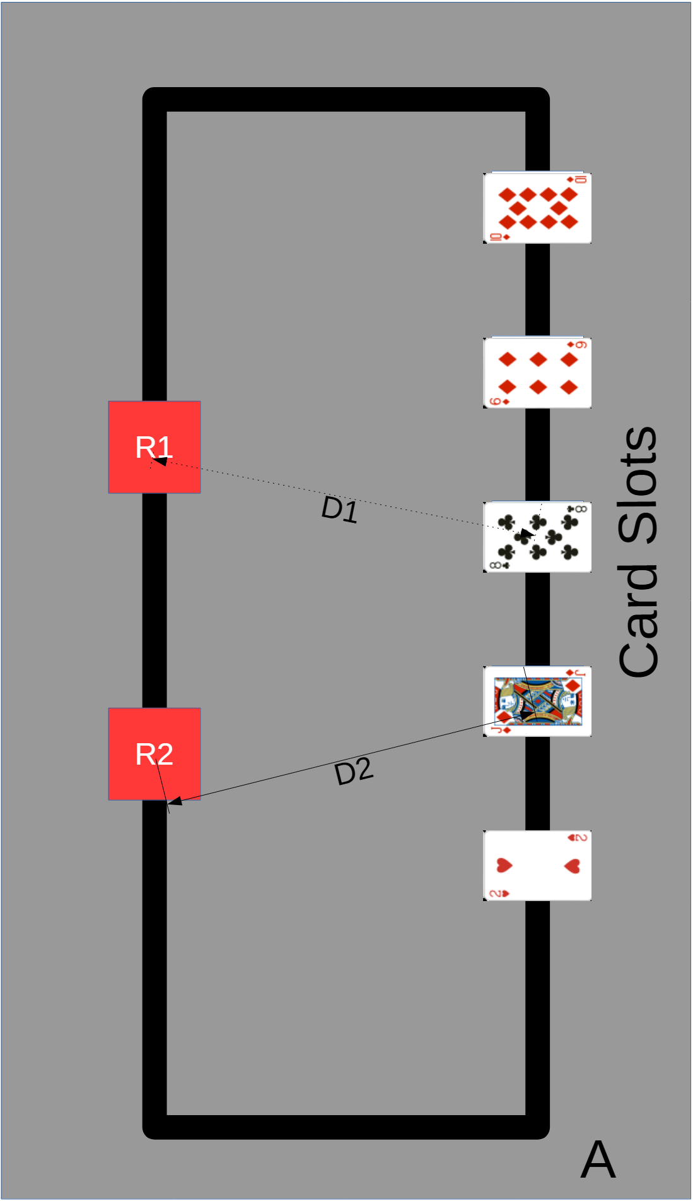
Fig. 1: Playing Field with slots for 5 playing cards. Robot must start at A pointing towards the cards. It must drive along the path and scan the cards. Then it must stop on the opposite track as close as possible to position of the target/highest card. Robot R1 has stopped closer to the 8 of Clubs than the target card (Jack of Diamonds). Hence R1 will receive a score of 1 point. R2 is closest to the target card and will receive a score of 10 points.

Robot
Robots must be able to move autonomously on the playing field using wheels, tracks, or feet.
The maximum size of the projection of the robot onto the ground is 210mm * 148.5mm (i.e., one half of an A4 sheet of paper).
A robot must use a maximum of four motors or other actuators. The number and type of sensors is not limited.

Game Play
The game play is described in the subsections below.

Playing Field
- The playing field is a wooden or plastic base with a high contrast colored rectangular track taped on top of it (for example, a black tape on gray background).
- There are five slots for playing cards to be added. The distance between the slots is approximately 20 cm.

Match
- The robot handler places the robot at position A pointing in the direction of the empty slots of for the playing cards.
- There are two sets of cards, the target card (i.e., the card that the robot must find) and the other cards (i.e., the remaining four cards).
U19:
The target card is a face card (Jack, Queen, King) in any suit (Hearts, Diamond, Clubs, Spades)
The other cards are the numbered cards Ace, 2,3,...10 in any suit (Hearts, Diamonds, Clubs, Spades).
U14:
The target card will be randomly selected and announced at the start of the preparation phase (e.g., we will announce the target card during the day is always the King of Clubs).
The other cards are the numbered cards Ace, 2,3,...10 in a single suit. The suit will be randomly selected and announced at the start of the preparation phase.
- The referee will shuffle both sets of cards randomly. The referee will then draw one target card (for U19) and four other cards. The referee will not show the drawn cards to the robot handler.
- The referee will shuffle the selected five cards randomly and will not show them to the robot handler.
- The referee starts the match (e.g., by blowing the whistle) and the robot handler will start the robot. The robot must remain stationary for five seconds.
- The referee will place the chosen target card and the other cards into the slots.
- The robot must track the line and identify the playing cards in the slots.
- The robot must come to a complete stop (I.e.., a stop longer than five seconds) on the opposite side of the track as close as possible to the position of the highest card on the opposite side.

Scoring
After the robot has come to a complete stop, the referee will measure the distance from the center of the robot to the target card and to the closest card.
If a robot leaves the track or does not stop, then it receives a score of 0 points.
If a robot stops on the opposite track, but the closest card is not the target card or it is closer to point A than the target card, it will receive 1 point.
If a robot stops on the opposite track and the closest card is the target card, then it will receive a score of 10 points.
The referee will record the number of points and the time taken for the run.
Tie-Breaker: If two teams have the same score after all rounds, then the time taken will be used as a tie breaker.

Organization and Scoring
The preparation time will consist of 2 hours.
The competition consists of two rounds.
At least 15 minutes before the round, all robots must be placed into quarantine. All robots in quarantine must be turned off. A team is not allowed to touch or send wireless commands to the robots in quarantine.
After all teams have completed the first round, they can work and reprogram their robot for 30 minutes to prepare for round 2. Then the robots must be put into quarantine again.
The top three teams will receive a certificate for 1st, 2nd, and 3rd place and 10, 8, 6 points respectively for the Mission Impossible All-Round competition.
Teams four to seven from the first phase will receive 4,3,2,1 points respectively for the Mission Impossible All-Round competition.
Failure to follow the instructions of the referee or other unsportsmanlike behavior will lead to disqualification.

